**Proof of concept**

**Problem:** We use hubspot as a CRM tool with a user interface to manage data like a web console. It is required for one person to pull the data from the tool and insert it into another tool. This idea requires manpower which may be costly day by day that solution is not feasible forever.

**Solution:** hubspot provides an API endpoint to consume data from the application without human interaction just we need to define which type of data we require, and our application will pull the data from the hubspot and insert it into the destination application.

hubspot develop one python package to pull the data.

<https://github.com/HubSpot/hubspot-api-python/tree/master>

We have developed one sample application to pull the contact details from the demo account.

Below is the screenshot where we can see contact details on hupspot site.

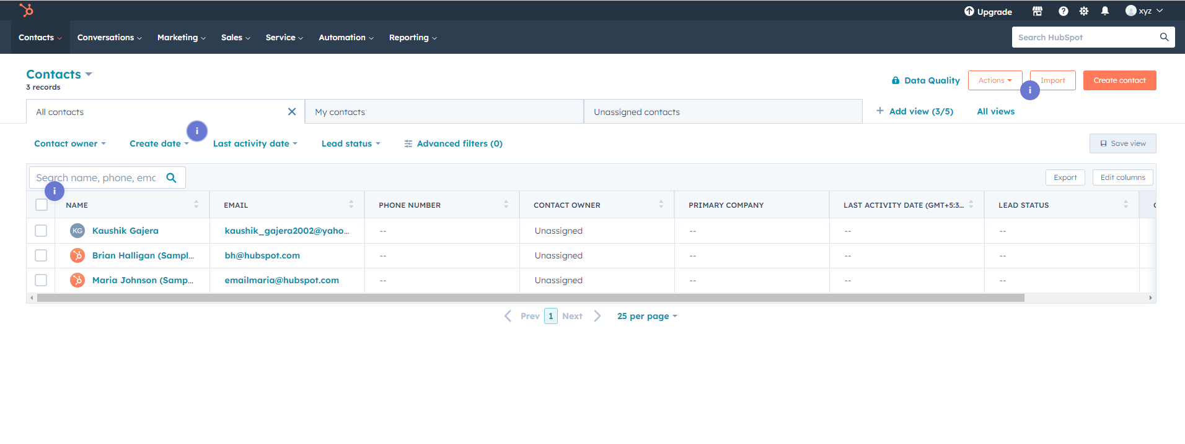Below is the screenshot of our application to pull the data from the hubspot using API call.

